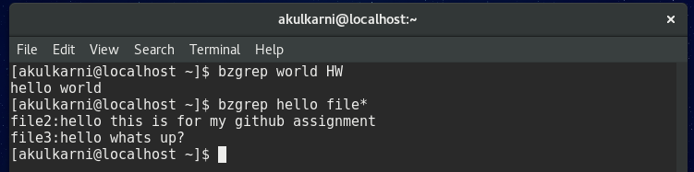
The grep command helps to find a particular string in a file as in the first example the command searches for the string world in HW file.
In the second example the command searches the string hello in all the file whose name starts with file.


Bzexe command compresses the files . in the example file .txt is just a txt file but after the command is executed one compressed file is created of the same file

